Berry Public School Nursery

Growing Plants – Growing Community:
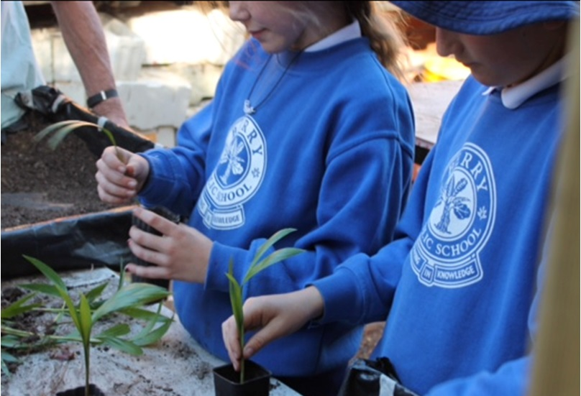
Each Thursday afternoon, a group of cheerful volunteers enjoys learning and sharing knowledge with each other and with a small group of children (in our purpose built nursery) about the plant species that grow in and around Berry, from the escarpment to the sea and from Foxground to Bomaderry. We have the satisfaction of knowing that we are doing something really useful to expand the children’s knowledge and understanding of their local natural environment.
With the help of volunteers, the children plant seeds, pot them up and grow them on and care for them until customers buy them (for a small donation) and carry them out of the nursery gates to a new home.
By including some local native plant species grown from locally sourced seed into your garden, you are providing the best choice for the local conditions and also assisting in the preservation of local wildlife species. We grow plants suitable for :- Town gardens, Larger gardens, Rural properties and farms, Regeneration sites, Landcare, Bushcare and Parkcare Sites.
Visitors are welcome. Usual opening hours are on Thursdays during school term from 1.00 – 3.00pm. Contact the school office for details on 44641158.

Weed and Native of Month:
At the recent Small Farm Field Day Shoalhaven Landcare shared the exhibit with Shoalhaven Council. The Council’s exhibit featured information about a local aquatic floating fern weed, Salvinia.molesta. Young leaves are flat and almost circular with a rough upper surface and trailing dark roots. As plants become more crowded the leaves fold. Salvinia is a Class 2 noxious weed and must be reported to the Council’s Noxious Weed’s officer.
Azolla.is a native floating fern that often blankets water surfaces. Its leaves may be green or reddish brown. Because it can completely cover ponds and dams it is often regarded as a weed and its blanketing effect means it excludes light from the water. This can result in anaerobic conditions.
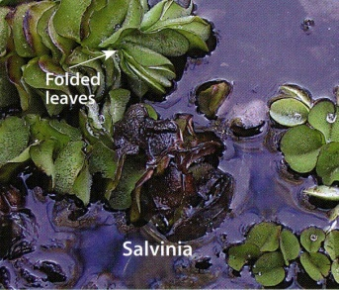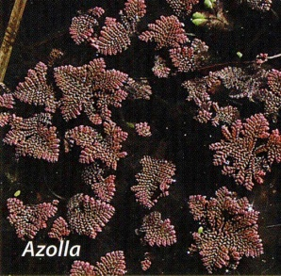

Working Bees for October 2015:
Alexandra Street Parkcare: 9-11 am 16th October: Gail Paton 44487915.
Bong Bong Road: 9-11am Sunday 11th October: Julia Woinarski 4464 2084.
Bundewallah Bushcare: 2-4pm Sunday 25th October: John Clark 44643911.
Camp Quality: 9-11am Sunday 18th October: Jeanne Highland 4464 1271.
Moeyan Hill: 2-4pm Saturday 17th October: Bill Pigott 44643241 or wpigott@bigpond.net.au.
Mount Coolangatta: 1-3 pm Saturday 17th October at end of Roxbrough Rd, Far Meadow.
Be on time to get a lift to site: Myke Cunningham 0418 297 435 or mcunningham@pci.cx.
Mark Radium Park: 9-10am Friday 23rd October: Rodney Cole 4464 1475.
Princess Street: 10-12am Thursday 15st October: John Cullity 0414 362 609, 4464 3327
Tindalls Lane: 2-4 pm Sunday 11th October: Harvey Blue 4464 1880 or Jim Jefferis 4464 2988.
Information can also be found at Berry Landcare on Facebook.
Plant identification service: Please contact Harvey Blue 4464 1880 or Ian Parker, 4448 6359.
Visit our pages at: http://www.landcare.nsw.gov.au/groups/berry-landcare for more on Berry Landcare and late changes to working bee details. Information can also be found on Facebook.

